compiler design notes
Writing a Grammar
Consider several transformations that could be applied to get a grammar more
suitable for parsing techniques like

•
•
•
Eliminate ambiguity
Left recursion elimination
Left factoring elimination

ϖ These techniques are useful for rewriting grammars to make suitable for
top-down parsing.
Lexical versus syntactic Analysis:
Use regular expressions to define the lexical syntax of a language. There are
several reasons.

ϖ

ϖ

ϖ

ϖ

ϖ

ϖ
Separating the syntactic structure of a language is to lexical and non-lexical parts
provides a convenient way of front end of compiler is to 2 manageable sized
components.
The lexical rules of a language are frequently quite simple and to describe don’t
need a notation as powerful as grammars.
Regular expressions generally provide a more concise and easier to understand
notation for tokens than grammars.
More efficient lexical analyzers can be constructed automatically from regular
expressions than from arbitrary grammars.
Regular expressions are most useful for describing the structure of constructs such
as identifiers, constants and keywords and white space.
Grammars are most useful for describing nested structures such as balanced

parentheses. Matching begin –ends, corresponding if-then-else’s and so on.

Eliminating ambiguity:
For example, consider the following dangling-else grammar

Prepared By Dipendra Air
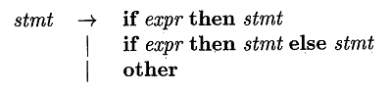

compiler design notes

-

The above grammar is ambiguous since the string
If E’ then if E2 then S1 else S2 has 2 parse trees as follows

The general disambiguating rule is “Match each else with the closest unmatched then”
The unambiguous grammar for if-then-else statement is as follows:
Stmt – matched stmt
1 open-stmt
Matched-stmt: if expr then matched stmt else matched-stmt

Prepared By Dipendra Air
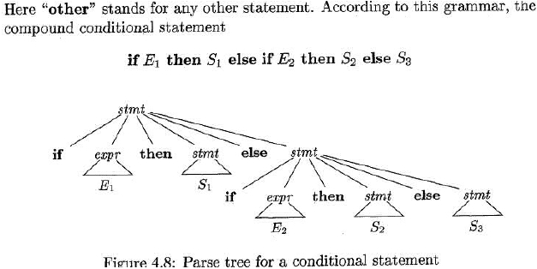

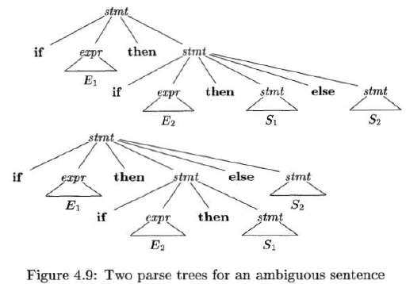

compiler design notes
1 other

Open-stmt :
if expr then stmt

1 if expr then matched-stmt else open-stmt

Elimination of left recursion:

A grammar is left recursive if it has a non terminal. A such that there is a
derivation A→ A for some string α
Consider immediate left recursion contains production of the form A→Aα
The left recursive pair of productions A → Aa | β
The non-left-recursive productions are

Example: The non-left-recursive expression grammar
E→ E + T | T
T→ T*F |F
F→ (E) | id

Elimination of left recursion:
E→ E +T | T
A→A α | β

E → T E’
E’→ +TE’| ε

T→ T *F | F
A→A α | β

T → F T’
T’→ * F T’| ε

[A→ βA]
[A’→ α A’ | ε ]

[A→ βA]
[A’→ α A’ | ε ]

F→ (E) | id
Prepared By Dipendra Air
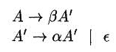

compiler design notes

Eg:

S → Aa | b
A → Ac | Sd | ε

The non terminal S is left recursive. i.e S → Aa→ Sda
recursive.
The non terminal A is immediately left recursion.
i.e
S → Aa | b
A→Ac | Aad | bd | ε

After eliminating left recursion
S → Aa | b
A→ bdA’ | A’
A’→ cA’ | adA’| ε

Algorithm for eliminating left recursion:

Input: Grammar G with no cycles or ε-Productions.
Output: An equivalent grammar with no left recursion.
Arrange the non terminal is some order A1, A2…An
for (each i from 1 to n)
{
for (each j from 1 to i-1)
{
replace each production of the form
Ai →Aj α by the productions
Ai → 81 α/ 82 α/….8kα, where
Ai → 81 / 82 /….8k are all current
Aj productions
Prepared By Dipendra Air
but is not immediately left

compiler design notes
}
eliminate the immediate left recursion among the Ai – productions
}

Left Factoring:

It is grammar transformation that is useful for producing a grammar suitable for
top-down parsing.
When there is a choice between two alternative A-Productions is not clear. Their rewrite
the productions to defer decision until enough of input make the right choice.

Generally
A →αβ1 / αβ2
Left factored the original productions become
A → α A’
A’→ β1 / β2
Eg:
S→iEtS /iEtSeS/a
E→b
Left factored this grammar becomes
S → i E t S S’ / a
S’ → e S / ε
E→b
Since
A →αβ1 / αβ2 /….α βn /γ
Then left factored becomes
A →α’A’/α
A’→ β1 / β2/…../βn

******

Prepared By Dipendra Air

compiler design notes
Top-Down parsing

Constructing a parse tree for the input string, starting from the root and creating
nodes of the parse tree.
If can be viewed as finding a left-most derivation for an input string.
Eg:
Consider the grammar
E → T E’
E’→ + T E’ /ε
T → F T’
T’→ * F T’/ ε
F → ( E ) / id
& input id+id

Prepared By Dipendra Air
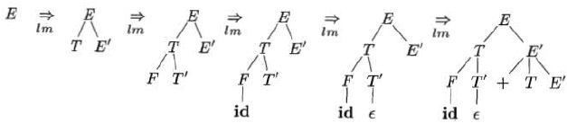

compiler design notes

Recursive – Descent parsing:

•
•
This parsing program consists of a set of procedures, one for each non terminal.
Execution begins with procedure for start symbol, which halts and announces success

if its procedure body scans the entire input string.
A typical procedure for a non terminal is a top-down parser
void A ()
{
choose as A-production A → X1, X2….XK;
for (i=1 to K)
{

if (Xi is a non terminal)

call procedure Xi();
Prepared By Dipendra Air
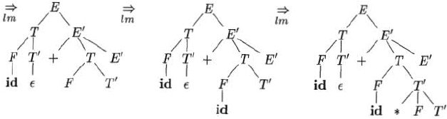

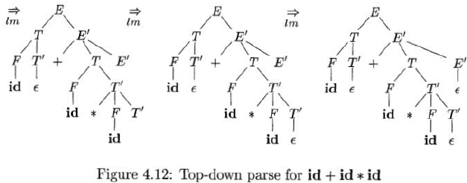

compiler design notes
else if (Xi equals the current input symbol a )
advance the input to next symbol;
else /* as error has occurred */;
}
}

•
General Recursive descent may require backtracking (i.e.) it may require repeated

sears over the input.
Example:
Consider the grammar
S→ cAd
A → ab/a
To construct a parse tree top-down for the input string w = cad,

•

•

Predictive parsing, a special case of recursive descent parsing where no backtracking
is required.
Predictive parsing choose the correct A – production by looking ahead at the input a

fixed no of symbols

First and Follow:

The construction of top-down and bottom-up parsers is aided by two functions
First and Follow

First (α):

Prepared By Dipendra Air
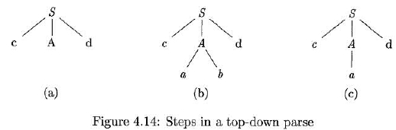

compiler design notes
- Where α is any string of grammar symbols to be set of terminals that begin
strings derived from α.
To compute First (X) for all grammar symbols X, applying the following rules until no
more terminals are found:
1. If X is a terminal, then FIRST (X) = {X}
2. If X is a non terminal and X →Y1,Y2….YK is a production for some k≥1, then
place a is FIRST(X) if for some i, a is FIRST(Yi).
If ε is FIRST(Yj) for all j = 1,2….k then add ε FIRST (X).
3. If X→ε is a production, then add ε to FIRST(X)

Eg:
E→E + T | T
T→T*F |F
F→ (E) | id
By applying left recursion,
E → T E’
E’ → + T E’/ ε

T → FT’
T’→ * F T’/ ε

F → (E) / id

First ( + ) = { + }
First ( * ) = { * }
First ( ( ) = { ( }
First ( ) ) = { ) }
First ( id ) = { id }

first ( E ) = { ( , id }
first ( E’) = { + , ε }
first ( T ) = { ( , id }
first ( T’) = { * , ε }
first ( F ) = { ( , id }

Follow (A):
for nonterminal A, to be the set of terminals a that can appear immediately to
the right of A in some sentential form.
i.e. the set of terminals a such that there exists a derivation of the form S →αAaβ,

To compute follow (A) for all non terminals A, apply the following rules until nothing
can be added can be added to any follow set.

Prepared By Dipendra Air

compiler design notes
1. Place $ is follow (S), where S is the start symbol and $ is the input right endmarker.
2. If there is a production A→ α B β, then everything is first (β) except ε is in follow (B)
follow (B) = first (β) - ε
3. If there is a production A→ α β, or a production A→ α B β, where first (β) contains
ε, then everything is follow (A) is in follow ( B)
follow(B) =follow(A)
Eg:
E → T E’
E’→ + T E’│ε
T → F T’
T’→ * F T’I │ε
F→( E ) │ id
To compute follow
Follow ( E ) = { $, ) }
Follow ( E’) = { $, ) }
Follow (T) = { +, $, ) }
Follow (T’) = { +, $, ) }
Follow (F) = { *, +, $, ) }
E → T E’:

A→ α B
Rule 3

Follow (E’) = Follow(E)
= { $, ) }

E’→ + T E’

A→αBβ
Rule -2

follow (T) = first (E’) – ε
= {+, ε} - ε
={+}
Applying E’→ ε in E’→ + T E’
E’→ + T ε
A→αBβ
Follow (T) = follow (E’)

Prepared By M. Raja, CSE, KLU

compiler design notes

T→ F T’
A → α B Rule – 2
Follow (T’) = first (T) – ε
= {*, ε} – ε
= {*}

T’→* F T’

A→αBβ
Rule 2

Follow (F) = First (T’) –ε
= {*, ε} – ε
={*}

T’ → * F T’/ ε
Apply T’ → ε
T’ → * F ε ➔ T’ → * F

A→ αBβ
Follow(F) =Follow (T’)

F → ( E ) / id
T’→ε Rule 3

F→(E)
Rule 2

A →α B β
Follow (E)= First ()) – ε
= {)} – ε
= {)}
F → id

L L (1) Grammars
Predictive parsers, that is recursive-descent parsers needing no backtracking can
be constructed for a class of grammars called LL(1)
Prepared By Dipendra Air

compiler design notes
The first "L" in LL(1) stands for scanning the input from left to right, the
second "L" for producing a leftmost derivation, and the "1" for using one input
symbol of lookahead at each step to make parsing action decisions.

Construction of a predictive parsing table:
Input: Grammar G
Output: parsing table M
Method: for each production A→α of the grammar, do the following:

•
•

•

•

•

•

•

•
For each terminal a is first (α), add A→α to M[A,a]
If ε is is first (α), then for each terminal b is follow (A), add A→α to M[A,b)

E → T E’
A → α Rule 1
First (TE’) = first (T) = {(, id}
Add E→ T E’ to M [E,( ] & M[E, id]

E→ +T E’ /ε
E→ +T E’
A→α
First (+T E’)= {+}
Add E→ +T E’ to M [E, +]

E’ →ε Rule 2
Follow (E’) = {),$ }
Add E’→ ε to M [E’, )] & M [M E ,$]

T → F T’ Rule 1
A →α
First (F T’)= First (f) = {}
Add T →F T’ to M [T,(] & M [ T, id]

T’→ *F T’ /ε
T’ → * F T’
A →α Rule 1
First (* F T’)= {*}
Add T →* F T’ to M [T’, *]

T’→ε
A→α Rule 2
Follow (T’) = {+, ), $}
Prepared By Dipendra Air

compiler design notes

•

•

F → (E) /id
F → (E)
A →α
First ( () )={(}
Add F → (E) to M [F,(]

F → id

A→α
First (id) = {id}
Add F→ id to M [F, id]

The parsing table M for the above grammar is as follows:

Non-
id
+
*
(
)
$

Terminal

E

E→ T E’

E→ T E’

E’

E’→+T

E’→ ε

E’→ ε

E'

T

T→ F T’

T→*F T’

T’

F

F→ id

T’→ ε

T’→*F T’

F→(E)

T’→ ε

T’→ ε

Non – recursive predictive parsing:
Non recursive predictive parser can be built by maintaining a stack explicitly, rather
than implicitly via recursive calls.
The table- driver predictive parser consists of

1.
2.
3.
4.
Input buffer
A stack containing a sequence of grammar symbols
A parsing table constructed by predictive parsing algorithm
As input stream.
Prepared By Dipendra Air

compiler design notes
The parser is controlled by a program that considers X, the top-symbol on stack and a,
the current input symbol

If X is a non terminal, the parser chooser X- Production from entry M[X,a].
Otherwise, it checks for a match between the terminal X and current input symbol a

Algorithm: Table – driven predictive parsing

Input: A string w & a parsing table M for grammar G
Output: If w is in L(G), a leftmost derivation of w otherwise an error indication.
Let a be the first symbol of w;
Let X be the top stack symbol;
While (x≠$)
{
/*stack is not empty */
If (x=a)
pop the stack and let a be the next symbol of w;
else
if (x is a terminal)
error();

Prepared By Dipendra Air
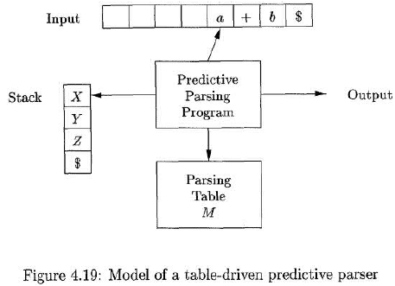

compiler design notes
else
if (M[x,a] is as error entry)
error ();
else
if (M[x,a]=x→y1, y2…..yk)
{
output the production x→ y1, y2…..yk)
pop the stack;
push yk, yk-1,….. y1 onto the stack, with y1 on top;
}
Let X be the top stack symbol;
}
Fig: Predictive parsing Algorithm

Eg:
On input id+ id*id, make sequence of more S using non recursive predictive parser
algorithm.
Moves made by a predictive parser on input id + id * id

Method
stack
input
Action

$E

$ E’T

$ E’T’F

$ E’ T’ id

id + id *id $

id + id *id $ Output E → TE’

id + id *id $ Output T → FT’

id + id *id $ Output F → id

id

$ E’T’

+ id *id $

match id

id

id+

id+

id+

id+

$ E’

$ E’ T +

$ E’T

$ E’ T’F

$ E’ T’id

+ id *id $ Output T’ → ε

+ id *id $ Output E’ → +TE’

id *id $ Match +

id *id $ Output T → FT’

id *id $ Output F → id

Prepared By Dipendra Air

compiler design notes

id+ id

id+ id

id+ id *

id+ id *

id+ id *id

id+ id *id

id+ id *id

$ E’T’

$ E’ T’ F *

$ E’ T’F

$ E’ T’id

$ E’ T’

$ E’

$

*id $ Match id

*id $ Output T’ → *FT’

id $ Match *

id$ Output F→ id

$ Match id

$ Output T’ → ε

$ Output E’ → ε

*******

Bottom up parsing

A bottom-up parse corresponds to the construction of a parse tree for an input
string beginning at the leaves (the bottom) and working up towards the root (the top).

Consider the grammar as
E→ E + T | T
T→ T*F | F
F→ (E) | id

A bottom-up parse for id * id

Prepared By Dipendra Air
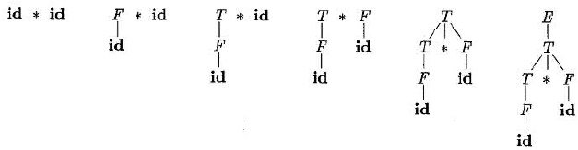

compiler design notes
Reductions:
Bottom-up parsing as the process of "reducing" a string w to the start symbol of
the grammar. At each reduction step, a specific substring matching the body of a
production is replaced by the nonterminal at the head of that production.

Handle Pruning:
"handle" is a substring that matches the body of a production, and whose
reduction represents one step along the reverse of a rightmost derivation.

if S → αAw → αβw, then production A→β, in the position α following a is a handle of
αβw.

Shift-Reduce Parsing:
Shift-reduce parsing is a form of bottom-up parsing in which a stack holds
grammar symbols and an input buffer holds the rest of the string to be parsed.
Initially, the stack is empty, and the string w is on the input, as follows:

If the parser accepts the input, then

Prepared By Dipendra Air

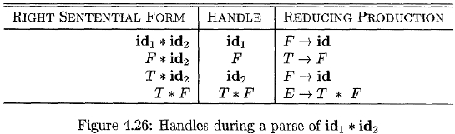

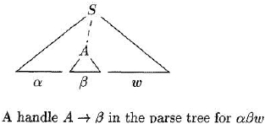

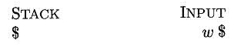

compiler design notes

The shift reduce parser for the input string id1*id2 as follows.

While the primary operations are shift and reduce, there are actually four possible
actions a shift-reduce parser can make: (1) shift, (2) reduce, (3) accept, and (4) error.

1. Shift. Shift the next input symbol onto the top of the stack.
2. Reduce. The right end of the string to be reduced must be at the top of the stack.
Locate the left end of the string within the stack and decide with what nonterminal to
replace the string.
3. Accept. Announce successful completion of parsing.
4. Error. Discover a syntax error and call an error recovery routine.

Conflicts during Shift-Reduce Parsing:

Every shift-reduce parser for such a grammar can reach a configuration in which
the parser, knowing the entire stack contents and the next K input symbol, cannot decide
whether to shift or to reduce (a shift/reduce conflict), or cannot decide which of several
reductions to make (a reduce/reduce conflict).

Operator precedence parsing:

Prepared By Dipendra Air
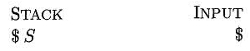

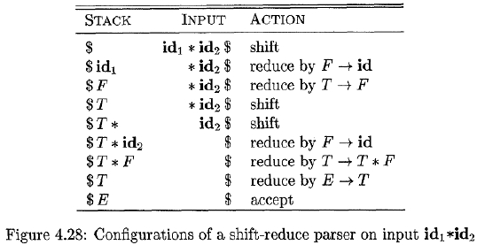

compiler design notes
We now look at operator-precedence parsing which is a form of shift-reduce
parsing. Two important properties for these shift-reduce parsers is that e does not appear
on the right side of any production and no production has two adjacent non-terminals.

A small but important class f grammars can easily construct efficient shift-reduce
parsers by hand.

The grammars have the properties that have no two adjacent non-terminals.

Eg:

Consider the following grammar for expressions.

E→ EAE | (E) | -E |id

A→ + |-| *| /| ↑

Substitute for A each of its alternatives, obtain the following operator grammar

E → E + E | E – E | E * E | E ↑ E | E / E | - E | (E) | id

Relation

a<b

a=b

a >b

Meaning

a yields precedence to b

a has same precedence as b

a takes precedence over b

Operator precedence relationship:

The right end marker for the string is $

The right sentential form id + id * id & operator precedence is as follows:

id

+

*

$

id

+

-

<

>

>

>

<

>

>

Prepared By Dipendra Air

compiler design notes

*

$
<

<
>

<
>

<
>

-

Introduction to LR Parsing: Simple LR
The most prevalent type of bottom-up parser today is based on a concept called
LR(k) parsing;
where
"L" - left-to-right scanning of the input,
"R" - constructing a rightmost derivation in reverse,
“ k” - the number of input symbols of lookahead that are used in making parsing
decisions.
The cases k = 0 or k = 1 are of practical interest, and we shall only consider
LR parsers with k 5 1 here. When (k) is omitted, k is assumed to be 1.
There are 3 kinds of parsing techniques
1. Simple LR Parsing or SLR Parsing
2. Canonical LR Parsing or CLR Parsing
3. Lookahead LR parsing or LALR Parsing

Simple LR Parsing or SLR Parsing:
This section introduces the basic concepts of LR parsing and the easiest
method for constructing shift-reduce parsers, called "simple LR" (or SLR, for short).
Why LR Parsers?
LR parsing is attractive for a variety of reasons:
1. LR parsers can be constructed to recognize virtually all programming language
constructs for which context-free grammars can be written.
2. The LR-parsing method is the most general nonbacktracking shift-reduce parsing
method known, yet it can be implemented as efficiently as other, more primitive
shift-reduce methods.
3. An LR parser can detect a syntactic error as soon as it is possible to do so on a
left-to-right scan of the input.
The principal drawback of the LR method is that it is too much work to
Prepared By Dipendra Air

compiler design notes
construct an LR parser by hand for a typical programming-language grammar. A
specialized tool, an LR parser generator, is needed.

Items and the LR(0) Automaton:

How does a shift-reduce parser know when to shift and when to reduce?
For example, with stack contents $ T and next input symbol * in the above problem
( Fig. 4.28), how does the parser know that T on the top of the stack is not a
handle, so the appropriate action is to shift and not to reduce T to E?
An LR parser makes shift-reduce decisions by maintaining states to keep track
of where we are in a parse. States represent sets of "items." An LR(0) item (item for
short) of a grammar G is a production of G with a dot at some position of the body.
Thus, production A → XYZ yields the four items.
A→ . XYZ
A→ X . YZ
A→ XY . Z
A→ XYZ .
The production A →ε. generates only one item, A → ..

an item indicates how much of a production we have seen at a given point in the
parsing process. For example, the item A →. X Y Z indicates that we hope to see a
string derivable from XYZ next on the input. Item A → X .Y Z indicates that we have
just seen on the input a string derivable from X and that we hope next to see a string
derivable from Y Z. Item A → X Y Z. indicates that we have seen the body XYZ and that
it may be time to reduce XYZ to A.

One collection of sets of LR(0) items, called the canonical LR(0) collection,
provides the basis for constructing a deterministic finite automaton that is used to make
parsing decisions. Such an automaton is called an LR(0) automaton.

Prepared By Dipendra Air

compiler design notes
To construct the canonical LR(0) collection for a grammar, we define an
augmented grammar and two functions, CLOSURE and GOTO. If G is a grammar with
start symbol S, then G', the augmented grammar for G, is G with a new start symbol S’
and production S’→ S. The purpose of this new starting production is to indicate to the
parser when it should stop parsing and announce acceptance of the input. That is,
acceptance occurs when and only when the parser is about to reduce by S’→ S.

Closure of item Sets:
If I is a set of items for a grammar G, then CLOSURE(I) is the set of
items constructed from I by the two rules:

1. Initially, add every item in I to CLOSURE(I).
2. If A→α.Bβ is in CLOSURE(I) and B → .γ is a production, then add the item B → .γ
to CLOSURE(I), if it is not already there. Apply this rule until no more new items
can be added to CLOSURE(I).

Example:
Consider the augmented expression grammar:
E→E+T|T
T→T*F|F
F → ( E ) | id

Augmented Grammar
I0: E’→ .E
E→.E+T
E→.T
T→.T*F
T→.F
F→.(E)
Prepared By Dipendra Air

compiler design notes
F→.id

I1: Goto (I0,E)
E’→E.
E→ E.+T

I2: Goto(I0, T)
E→T.
T→T.*F

I3:Goto (I0,F)

T→F.
completed

I4: Goto (I0,( )
F→(.E)
E→.E+T
E→.T
T→.F
T→.T*F
F→.(E)
F→ .id

I5: Goto (I0,id)

F→ id.
completed

I6: Goto (I1,+)
E→E+.T
T→.F
T→.T*F
F→.(E)
F→.id

Prepared By Dipendra Air

compiler design notes
I7: Goto(I2,*)
T→T*.F
F→.(E)
F→.id

I8: Goto (I4, E)
F→ (E.)
E→ E .+T

I2: Goto (I4, T)
E→T.
T→T.*F

I3: Goto (I4, F)
T→F.

I4: Goto(I4,( )
F→(.E)
E→.E+T
E→.T
T→.T*F
T→.F
F→.(E)
F→id

I5: goto (I4,id)
F→id.

I9: goto (I6,T)
Prepared By Dipendra Air

compiler design notes
E→E+T.
T→T.*F

I5: goto(I6,F)
T→F.

I4: goto(I6,( )
I5: goto (I6,ID)
I10: goto (I7,F)
I4: goto(I7,( )
I5: goto (I7, id)
I11: goto(I8,) )
I6: goto (I8,+)
I7: goto (I9,*)

Stack

Input string

Action

$0

$ 0 id 5

$0F3

id * id + id $ Shift

* id + id $ Reduce F→ id

* id + id $ Reduce T→ F
Prepared By Dipendra Air
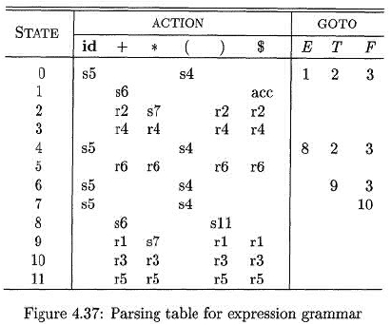

compiler design notes

$0T

$0T2

$0T2*7

$ 0 T 2 * 7 id 5

$0T2*7F

$ 0 T 2 * 7 F 10

$0T

$0T2

$0E1

$ 0 E 1+6

$ 0 E 1+6 id 5

$ 0 E 1+6 F

$ 0 E 1+6 F 3

$ 0 E 1+6 T 9

$0E1

* id + id $ Shift

* id + id $

id + id $ Shift

+ id $ Reduce F→ id

+ id $ Reduce T→T*F

+ id $

+ id $ Reduce E→T

+ id $

+ id $ Shift

id $ Shift

$ Reduce F→ id

$

$ Reduce T→F

$ Reduce E → E+T

$ Accept

Most powerful LR Parsers

In this section, we shall extend the previous LR parsing techniques to use one
symbol of lookahead on the input. There are two different methods:

1. The "canonical-LR" or just "LR" method, which makes full use of the
lookahead symbol(s). This method uses a large set of items, called the LR(1) items.

2. The "lookahead-LR" or "LALR" method, which is based on the LR(0) sets of items,
and has many fewer states than typical parsers based on the LR(1) items.

Canonical LR (1) Items (CLR):

The general form of an item LR (1) item becomes [A→ α . β, a], where A→ α β is
a production and a is a terminal or the right endmarker $.

In LR(1) item, the 1 refers to the length of the second component, called the lookahead
of the item

Constructing LR (1) Sets of Items
Prepared By Dipendra Air

compiler design notes
The sets of LR(1) items construction for grammar G is as follows:

Algorithm for construction of sets of LR(1) items is as follows.

Ex:

Consider the grammar,

S→CC

C→cC|d

r1: S → C C

r2: C → c C

Prepared By Dipendra Air
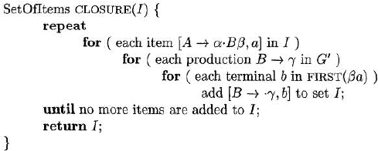

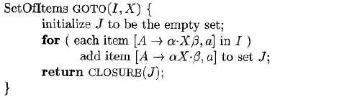

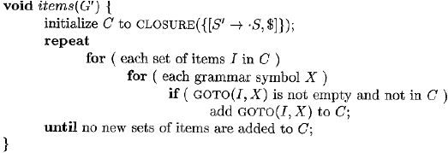

compiler design notes
r3: C → d

The augmented grammar G’

S’ → S

S→CC

C→cC|d

Prepared By Dipendra Air
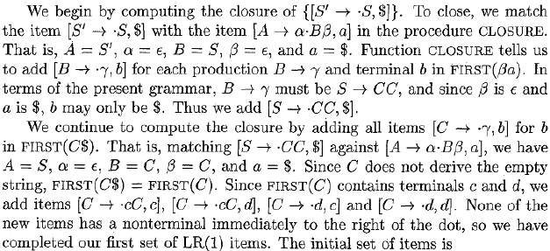

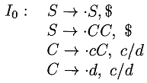

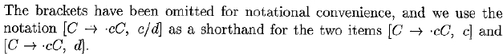

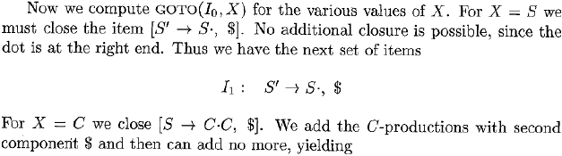

compiler design notes

Prepared By Dipendra Air
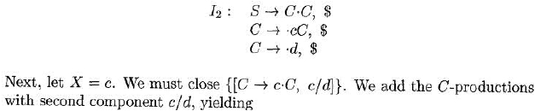

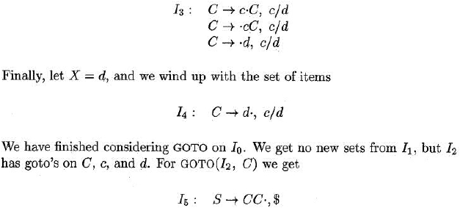

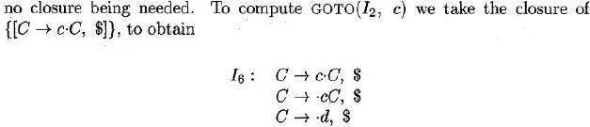

compiler design notes

Canonical LR(1) Parsing Tables:

Prepared By Dipendra Air
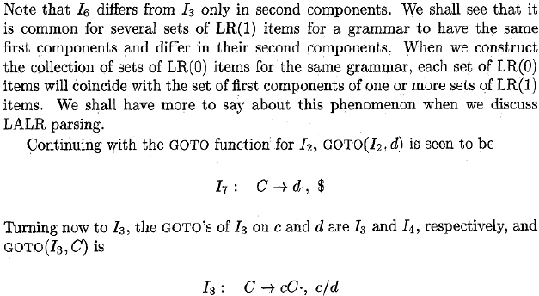

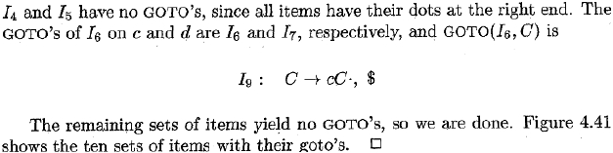

compiler design notes

Prepared By Dipendra Air
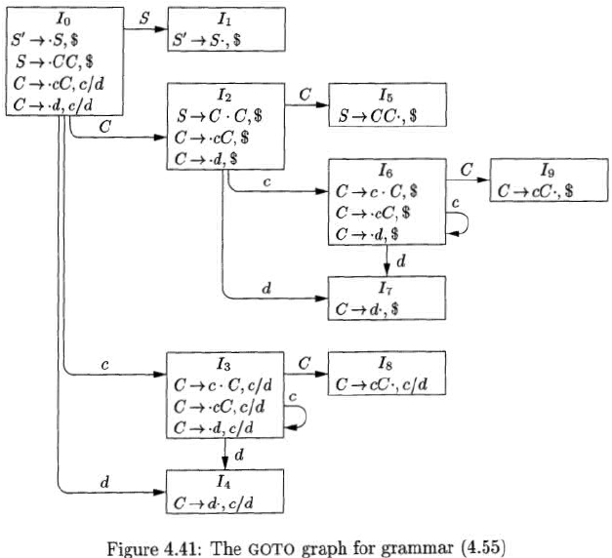

compiler design notes

Prepared By Dipendra Air
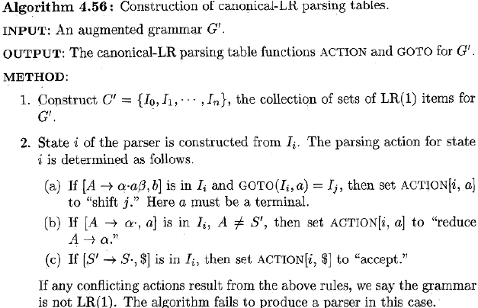

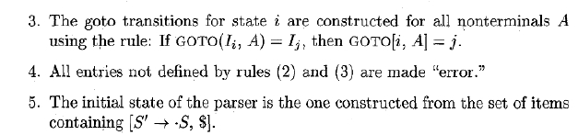

compiler design notes

Constructing LALR Parsing Tables:

We now introduce our last parser construction method, the LALR (lookahead-LR)
technique. This method is often used in practice, because the tables obtained by it are
considerably smaller than the canonical LR tables.

Most common syntactic constructs of programming languages can be expressed
conveniently by an LALR grammar. The same is almost true for SLR grammars but
there are a few constructs that cannot be conveniently handled by SLR techniques.

For a comparison of parser size, the SLR and LALR tables for a grammar
always have the same number of states, and this number is typically several
hundred states for a language like C.

Thus SLR & LALR are easier & more economical to construct

Prepared By Dipendra Air
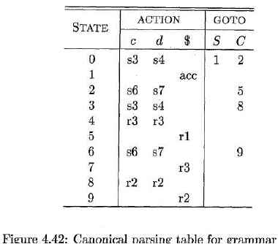

compiler design notes

Eg:

S→CC

C→cC|d

Prepared By Dipendra Air
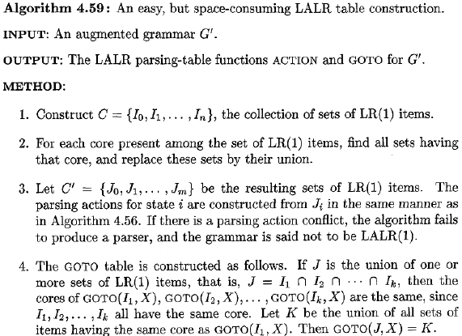

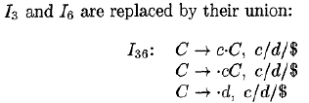

compiler design notes

Prepared By Dipendra Air
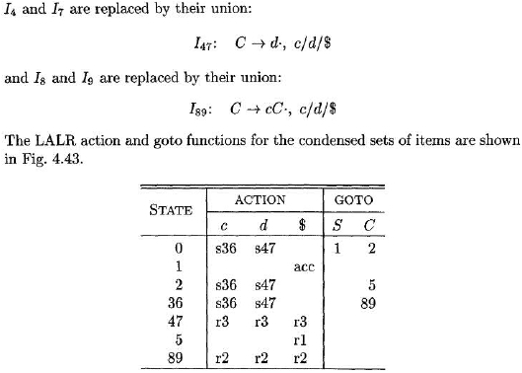

compiler design notes
Using Ambiguous Grammars

•

•

•

Every ambiguous grammar fails to be LR and thus is not is any of the classes of
grammar.
It all cases specify disambiguating rules that allows only one parse tree for each
sentence.
Thus overall language specification becomes unambiguous

Precedence and associativity to resolve conflicts:

Consider the ambiguous grammar for expressions with operators + & * as follows

E → E + E / E * E / ( E ) / id

It doesn’t specify the associativity or precedence of the operators + & *

The unambiguous grammar includes production

E→ E + T

T→ T + F

Gives + lower precedence than *

The sets of LR (0) items for the ambiguous expression grammar gives parsing action
conflicts.

The SLR approach to constructing the parsing action table as follows.

The sets of LR (0) items for an augmented expression grammar as follows.

I0: E’→ .E
E→ .E+E
E→ .E*E
E→ .(E)
E→ .id

I1: Goto (I0 ,E)
E’→ .E
E → .E+E
E → E.*E

I2: Goto (I0 ,( )
E’ → (.E)

Prepared By Dipendra Air

compiler design notes
E → .E+E
E → .E*E
E → .(E)
E → .id

I3: Goto (I0 ,id )
E→ id. Completed

I4: Goto (I1 ,+ )
E→ E+ .E
E→ .E+E
E→ .E*E
E→ .(E)
E→ .id

I5: Goto (I1 ,* )
E→ E* .E
E→ .E+E
E→ .E*E
E→ .(E)
E→ .id

I6: Goto (I2 ,E )
E→ ( E.)
E→ E. +E
E→ E. * E

I2: Goto (I2 ,( )

I3: Goto (I2 ,id )

I7: Goto (I4 ,E )
E→ E + . E
E→ E . + E
E→ E . * E

I2: Goto (I4 ,( )

I3: Goto (I4 ,id )

I8: Goto ( I5 ,E )
Prepared By Dipendra Air

compiler design notes
E→E+E.
E→E.+E
E→E.*E

I2: Goto (I5 ,( )

I3: Goto (I5 ,id)

I9: Goto (I6 , ) )

E→(E). Completed

I4: Goto (I6 ,+ )

I5: Goto (I6 ,*)

I4: Goto (76 ,+ )

I5: Goto (I7,* )

I4: Goto (I8 ,+ )

I5: Goto (I8 ,* )

The parsing table for the above grammar is

Prepared By Dipendra Air
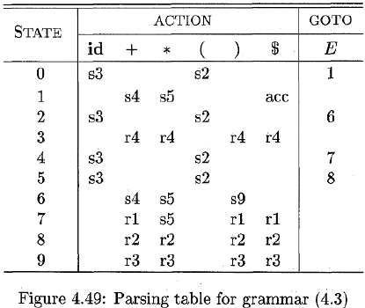

compiler design notes
The “Dargling-Else” Ambiguity

Consider the grammar for conditional strnts

Stmt → if expr then stmt else stmt

│if expr then stmt

│ other

S → i SeS/ i S / a

Augmenting production as

S’→S

S → i SeS/ i S / a

The LR (0) States for augmented grammar is

I0: S’→.S

S→.i SeS

S→.i S

S→.a

I1: Gogo (I0, S)

I2: Gogo (I0, i)

S→i.SeS

S→i.SeS

S→I . S

S→.i SeS

S→.I S

S→.a

I3: Gogo (I2, s)

S→a.

I4: Gogo (I2, s)

Prepared By Dipendra Air

compiler design notes
S→I S.eS

I2: Gogo (I2, i)

S→i.SeS

S→.i SeS

S→ .i S

S→.a

The LR Parsing table for the “dangling-else” grammar as follows:

The parsing actions of input iiaea as follows.

Prepared By Dipendra Air
